Works Cited
Center the title, and capitalize and spell it correctly
Use a “hanging indent” – indent backwards: one way to do this is to highlight everything and use the little up arrow in the middle (vertically) on the ruler
"Blueprint Lays Out Clear Path for Climate Action." Environmental Defense Fund. Environmental Defense Fund, 8 May 2007. Web. 24 May 2009.
Clinton, Bill. Interview by Andrew C. Revkin. “Clinton on Climate Change.” New York Times. New York Times, May 2007. Web. 25 May 2009.
Dean, Cornelia. "Executive on a Mission: Saving the Planet." New York Times. New York Times, 22 May 2007. Web. 25 May 2009.
Ebert, Roger. "An Inconvenient Truth." Rev. of An Inconvenient Truth, dir. Davis Guggenheim. Rogerebert.com. Sun-Times News Group, 2 June 2006. Web. 24 May 2009.
GlobalWarming.org. Cooler Heads Coalition, 2007. Web. 24 May 2009.
Gowdy, John. "Avoiding Self-organized Extinction: Toward a Co-evolutionary Economics of Sustainability." International Journal of Sustainable Development and World Ecology 14.1 (2007): 27-36. Print.
An Inconvenient Truth. Dir. Davis Guggenheim. Perf. Al Gore, Billy West. Paramount, 2006. DVD.
Leroux, Marcel. Global Warming: Myth Or Reality?: The Erring Ways of Climatology. New York: Springer, 2005. Print.
Milken, Michael, Gary Becker, Myron Scholes, and Daniel Kahneman. "On Global Warming and Financial Imbalances." New Perspectives Quarterly 23.4 (2006): 63. Print
Nordhaus, William D. "After Kyoto: Alternative Mechanisms to Control Global Warming." American Economic Review 96.2 (2006): 31-34. Print.
Shulte, Bret. "Putting a Price on Pollution." Usnews.com. US News & World Rept., 6 May 2007. Web. 24 May 2009.
Notice that this part is double spaced, Times New Roman, 12 point font just like everything else. It goes on a separate page at the end of the paper. If it’s a short paper, outline, etc., it’s probably OK to put it on the same page to save paper.
Put the entries in alphabetical order (A>>Z) by the first letter of the entry (usually author, but if there’s no author, whatever is first)
Best way I know to make a Works Cited page:
- Open a word document and write Works Cited at the top.
- In another window on your screen, create citations for sources you are using, and paste them onto your Works Cited page:
If you are using a database, they will have a button to click that automatically gives you a citation. Be sure to choose MLA, or whichever style your assignment asks for – you may have to scroll down a menu to find it.
If you are not using a source that has a ready-made citation for you, open a new window or tab on your browser and use an online citation generator. Here are two of many choices:
Easy Bib: http://www.easybib.com/
- Paste a url (web address) in the box
- Continue
- Add any other information you have (you might not have any more)
- Copy the citation & paste to your Works Cited page
Knight Cite: https://www.calvin.edu/library/knightcite/
- Choose MLA 7th (or another style if your assignment asks for it)
- Choose the kind of source
- Put all the information you have in the form (often you can’t find all of it), being careful to follow the patterns they give you under the boxes
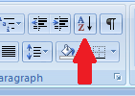
- Copy the citation & paste to your Works Cited page
After you have all your sources on the page (you can still add more later),
- Highlight everything
- Double space, remove space before/after paragraphs, Times New Roman 12 point font
- Alphabetize A > Z by whatever is first (look up in the middle of the toolbar:
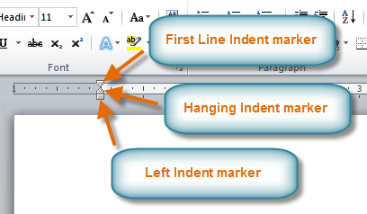
- set the Hanging Indent with the arrow in the middle:

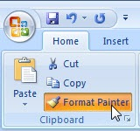
Note: if things still look weird because they don’t want to lose their formatting, try using Format Painter: highlight a word that looks right, click the painter, then paint the format on other words. Caution: you may have to re-italicize words after this.

Other helpful sites for MLA style:
http://honolulu.hawaii.edu/library/mlahcc7th.html
http://www.liu.edu/cwis/cwp/library/workshop/citmla.htm

- created by Gabe Winer

